Alpha Constitution

Name and Objectives
Alpha aims to cultivate a group of high-quality all-around talents and become an outstanding student leader team of Wenzhou-Kean University and an excellent organization for cultivating talents for overall development. Through further resource sharing and training for organization members, guide and help members clarify the current level of career development awareness of the university and enhance the subjective initiative of members for self-planning and self-development. Through practice and challenge, members can explore their advantages, improve their self-awareness, and fully discover, exercise, play, and maintain their value to the greatest extent.

Membership
The organization will select the selected members through strict selection, basic information filtering, group interview, task-based interview, and final assessment. All Wenzhou—Kean University students can participate in Alpha recruitment at the beginning of the autumn semester. Presidium and executive board members have the right to final decision and interpretation on the final selection results. Alpha states that it will not deny membership based on race, marital status, color, religion, gender, age, national origin, emotional or sexual orientation, disability, or military service obligations.

Structure

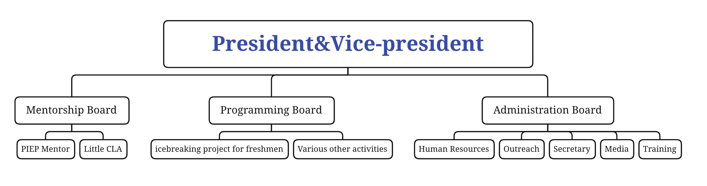

Officers and Duties

The organization has the following personnel: president, vice president, seven executive board members, and several organization members.

The duties of this personnel are as follows:

President: Determine the goals and tasks of the organization's annual development direction, coordinate, and allocate the central work at each stage, supervise, and coordinate the daily work of various departments, strengthen the unity and cohesion of internal personnel, strive for more high-quality resources for the members of the organization, and lead the organization to develop work.

Vice-President: Assist the chairman in daily work, do an excellent job in the division of labor, improve the efficiency of the department, and strengthen the construction and development of the department

executive board members: The executive board composed of outstanding talents is an essential part of Alpha. It has the characteristics of guiding the work, promoting the smooth progress of the work, and occupying important positions: specific work functions, unified coordination of management, supervision, organization, and the right to vote.

Organize the work content and objectives of all members: do an excellent job in organizational system construction and financial, performance evaluation, and file management; handle the work review of the organization members and the evaluation and summary of the work of each department, strengthen the relationship with the school's student organizations and clubs; to the organization Propaganda and report on significant issues and events, WeChat public account and QQ assistant operation, responsible for daily operations such as tweet poster production, photography and technology; responsible for the essential planning of daily activities, exploring and carrying out large-scale high-quality activities, and coordinating work with various departments Do an excellent job in the preliminary planning, timely feedback problems and make emergency measures; responsible for outreach and organization cooperation, strengthen the organization's external contacts, actively create conditions, strive for maximum support, and strengthen exchanges and cooperation with school organizations and clubs; Strive to expand the organization's external influence, and strive for the organization's most effective services inside and outside the school; receive training and learning within the organization, be competent for the appropriate roles and tasks arranged by the organization, train to become all-round development talents, and prepare for the new round of work handover.

Meetings
Organize regular meetings and special meetings. The routine meeting is a monthly work summary and outlook. We will update the current work, feedback the completed work, and adjust and improve the problems in the work or operation. All staff must attend the regular meeting. The attendance will be included in the performance appraisal; Special meetings are divided into emergency meetings and internal group meetings, which are held according to the actual situation. Emergency meetings are prepared for urgent events, and the group leader holds internal group meetings, who attends the meetings according to the actual participation and demand.

Standing Committees
PIEP Mentor: This project is a large-scale project organized by Alpha and the school during the opening season of each year. The Mentor is presented in the image of student Mentor, aiming to provide essential support for new freshmen in study and life, lead them to get familiar with the campus and academic rhythm gradually, and gradually adapt to the school life. The number of mentors is determined by the number of classes arranged by the school, and each class is guaranteed to have Mentor support and help professor. Mentor classroom assistance depends on the arrangement of the school and the professor, flexible.

Large-scale icebreaking project for freshmen: This project is a large-scale league building activity for all freshmen at the beginning of the new term, aiming to break the barriers between freshmen, make them quickly get to know and get familiar with each other, help them integrate into the new group, and eliminate the sense of insecurity. Since 2019, the project has been organized, planned, implemented, and optimized by the Alpha elite team led by the instructor of the Student Leadership Center.

Orientation activity on campus: This is a large-scale collective activity for all freshmen at the beginning of the new term. It aims to help freshmen know more about the campus, make them quickly know and get familiar with the functions of various places in the school, and cultivate their sense of community and responsibility.

Elections and Vacancies
Alpha began preparing for the election of a president, vice president, and executive board members in early May, which was announced in a general meeting. All executive board members are required to be members of the Alpha who have served for one year. Candidates must submit an annual development report of Alpha for the next year with no limit of words. Based on their daily performance, the results will be determined by the advisor and original members. The Alpha President and Vice-President are elected in the following year, and the candidates must be members of the Alpha executive board members who serve a full term of one year. The shortlisted candidates for the presidium team are determined to be made up of two parts, with 50% of the votes cast by the executive board members and 50% of the votes cast by all Alpha members. The above selection process was open and fair. Suppose there is a vacancy situation, such as resignation due to illness or particular reasons. In that case, the officer, the bureau, and the committee will discuss the suitable candidates, and the new staff will take up the post after reporting to the management department. All elected positions must meet Wenzhou-Kean University student leadership standards.

Removal and Succession of Officers
Reasons for the removal of an official
1. Those who are late or absent for meetings often violate the organization's rules, make mistakes in principle, and cause a profound adverse impact on the organization. In severe cases, such as written warning or punishment above, will be dismissed Alpha.

2. The officials do not listen to the suggestions of the organization members, do not fit in with the group, and the overall response of the officials is not good. Those who drag the organization back will be punished according to the seriousness of the case, and those who are extremely serious will be removed from the post.

3. Those with improper behavior and immoral conduct, who have been severely dealt with by the school, who privately slander the organization's image and cause a bad mood, will be dismissed. A motion to approve the removal of an officer requires a two-thirds plus percentage of management members, and notice must be given to the organization's entire membership before a vote can be taken.

Amendments
When there is a significant disconnect or discrepancy in implementing the organizational operating framework, management will revise the organizational structure and purpose. The members who approve the revision shall be all the members of the management and the members of the organization with extraordinary contributions. When considering the revision, a notice shall be issued to all the members, and the final draft shall be publicized to all the members of the organization in the regular meeting after the revision.

Advisor

Student Academic Support Center: Wu Jiang

University Regulations
The organization fully complies with all the rules, regulations, and policies of Wenzhou-Kean University.

