创行主席团信息
创行主席
I am Li Xinfang. As a freshman, I entered one of the projects in Enactus. And I started to make DIY products of the local embroidery，promotional videos and brochures. As a project presenter, I participated in the Idea Challenge Competition, simulation competition, and regional competition of Zhejiang province. A year later, I became executive director of Enactus during the election campaign. At the same time, I received a job offer from the headquarters of Zhejiang Province, responsible for the collection of project information and direct guidance of all Enactus‘ teams in Zhejiang province. And I have organized some activities like the autumn summit of Enactus and online national competition. In the future, I hope that I can lead all members to finish every task successfully and let them feel the charm of Enactus of WKU.
我是李欣芳。一进大一，我就进入了创行的锦绣虔诚项目组，开始了DIY产品，宣传视频，宣传手册的制备过程中。其中，作为项目陈述者，参加了IC挑战赛，模拟赛，区域赛。在大一时期，我也曾作为大一唯一一个学生代表去参加联合国和平峰会。一年之后，我成功在换届竞选上，成功担任创行行政总监。同时，我收到了大区的创行总部工作offer，成功担任了浙江大区的项目专员，负责所有浙江省的创行团队的项目信息收集，以及项目方向的指导。在此期间，也组织了秋培等活动，和线上国赛活动等。未来一年，我希望我能带领队员们成功完成每一项任务，并且能让他们感觉到创行的魅力！

创行副主席 （项目）
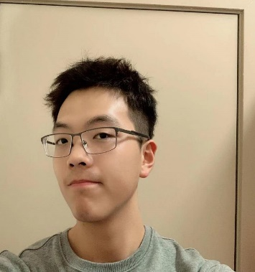
My name is Ye Chuhan, a sophomore majoring in finance in Wenzhou Kean University. I am working as the project director in Enactus Club. I have rich project experience, participated in project conclusion and project incubation, and have my own experience in project management as well. From the Rot To Treasure Department to New Project Development Department, to the Finger Rift Sunshine Department, sufficient project experience makes me believe that I am qualified for the position of project director.
我是叶楚涵，目前是温州肯恩大学的一名金融专业的大二学生，在领创担任项目总监一职。我的项目经历比较丰富，参与过项目的结项，也参与过项目的孵化，对项目的经营也有自己的心得。从化腐为宝到新项目开发，再到指缝阳光。充足的项目经验使我相信我能胜任项目总监这一职位。
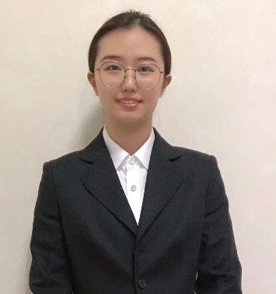
创行副主席 （行政）
Hello, my name is Wang Hao. I am a junior student major in Management Science, Supply Chain Management especially. At present, I am the executive director of the Enactus of Wenzhou Kean University, and I have three years of experience in Enactus. I once served as the director of the public relations department of Enactus that taught me a lot, and I also found the challenges and opportunities that the team is facing. I will try my best to make our team better in the near future.
大家好，我叫王皓。我是一名大三的学生，专业是管理科学，供应链管理方向。我目前担任温州肯恩大学领创团队的行政总监，在创行已经有三年的经验了。我曾担任温肯领创公关部部长，收获很多，也发现了团队正在面临的挑战也机遇，我将在接下来的时间里尽我所能的让我们的团队做得更好。

