**2025 *ECHO-ENG Volume 6* Submission Guidelines**

**Submit:**

1. **Submission email address:** [echo-eng@wku.edu.cn](mailto:echo-eng@wku.edu.cn) (use student Kean email or WKU email)
2. **Email Subject:** Volume 6 +your name + **Project** + your work’s title
3. **Email Body:** Your Student ID + Your Chinese and English name + **Project** + your work’s title + email address + word count.
4. **Due date:** 5 pm onNovember 4, 2025
5. **Language:** Both English and Chinese writings are accepted.
6. **Submission Guidelines:** also published on ECHO-ENG’s website: <https://club.wku.edu.cn/club/detail/108>



**Projects:**

1.Literature & Translation

2.Wenzhou Life

3.Reviews

4.Art

5.Major Life

6.WKU / Kean Campus Life

**Project Details & Recruitment Groups:**

1. **Literature & Translation​**

* Fiction​
* Poetry​
* Creative Non-Fiction​
* Drama​
* Electronic Literature​
* Original Translation​
* Commentary
* Chinese writing submission (We will hold workshops to support your English translation)
* Coursework: ​Senior Capstone project​, Creative Writing, World Literature ​
* Fan Fictions​

1. **Major Life​**

* **Self-Discovery & Exploration**
* **Standout Courses & Why You Like Them**
* **Lessons Learned from Course Projects**
* **Freshman Year Transformation**
* **Academic Challenges and Study Strategies**
* **Research Narratives & Student Research Experience**
* **Extracurriculars & Major-Related Projects**
* **Changing Majors: Reasons & Reflections**
* **Minoring Insights: Experiences & Tips**
* **Learning Reflections & Life Lessons**

1. **Reviews​**

* **Book Review: ex. Chinese book, English book, Comic book, Graphic book**
* **Film Review**
* **Art/Paintings Review**
* **Video Game Review**
* **Documentary /TV Series/** Animation Review
* **Event/Activity Review**

1. **Wenzhou Life​**

* **Your Trip: Travel Writing**
* **Wenzhou Local Events, Festivals & Activities**
* **Restaurant: Wenzhou cuisine**
* **Shop Recommendations**
* **Wenzhou Career & Business**
* **Photographing**

1. **WKU / Kean Campus Life**

* WKU/Kean Exchange Story
* Student Clubs/Organizations Participation
* Interest Groups/Projects
* Lectures/ Events/ Festivals
* Interviewing Communities
* Your Role on Campus
* Finding and Developing our Interests
* Advise Sharing
* How We Were Changed Here

1. **Art​**

* Art Appreciation: Paintings, comics, photo collections, sculpture, and exhibitions. Art analysis, reflections, or critique submissions based on well-known or student-selected works;
* Comic: Accepts your original comics, including continuations or reinterpretations of classics; Explore modern, imaginative interpretations; Focus on creative storytelling from daily life or fantasy.
* Artist Recommends: Art styles, movements, and recent exhibitions (on/off campus); Cross-disciplinary inspirations (music, film, architecture, literature); Personal reflections and creative insights.
* Photography: Nature; architecture; plants; animals; cultural or human-centered content;

**Format:**

1. Typed, double-spaced.
2. 1” margins on all sides, justified.
3. Times New Roman/SimSun(中易宋体), size 12.
4. Submit in a Word document (doc. or docx.).
5. All works require a title.
6. Image: JPG format, preferably in the high-definition version of the picture.

Multiple images should be sent as a compressed package.

**Artificial Intelligence(AI) Policy:**

1. Submissions must be the **original works** of human writers.
2. We currently do not accept works that are solely or predominantly generated by AI systems.
3. ECHO-ENG requires that authors disclose and explain any use of AI-assisted technologies in any part of the work on both the manuscript and the email body.
4. In the future, ECHO-ENG might develop certain kinds of submissions where AI writing can be permitted.

**Publication Notice:**

1. By submitting your work, you agree that it may be archived in WIRE (Wenzhou-Kean University Intellectual Research Environment at [*https://wkuwire.org/*](https://wkuwire.org/)). All accepted submissions will be published in ECHO-ENG Volume 6 and hosted on WIRE. If your accepted work will be submitted to other publications in the future, please notify both WIRE and ECHO-ENG in advance.

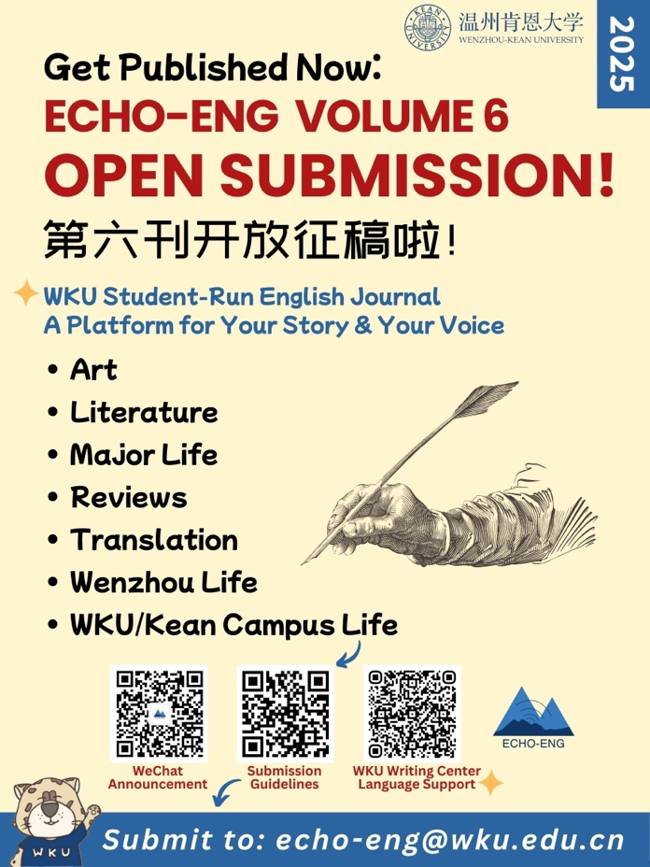

**Chinese Version📢 2025年《ECHO-ENG》第六期征稿指南**

**✅ 投稿方式：**

1. 投稿邮箱： [echo-eng@wku.edu.cn](mailto:echo-eng@wku.edu.cn) （请使用美肯邮箱 或 温肯邮箱发送）
2. 邮件标题格式： Volume 6 + 姓名 + **项目类型** + 作品标题
3. 邮件正文内容：
4. 学号+中文姓名和英文姓名+项目类型+作品标题+邮箱地址+作品字数
5. 投稿截止时间： 2025年11月4日 17：00
6. 语言： 接受中文和英文作品投稿
7. 详细投稿指南发布链接：  
   👉 <https://club.wku.edu.cn/club/detail/108>

**✍️ 投稿项目类型：**

1. 文学与翻译类 Literature & Translation

2. 专业生活 Major Life

3. 评析类 Reviews

4. 温州生活 Wenzhou Life

5. 温肯/美肯校园生活 WKU / Kean Campus Life

6. 艺术作品 Art

**格式：**

1. 打字，双倍行距页面。
2. 各边1英寸页边距、齐行对齐。
3. 字体Times New Roman/ 中易宋体，12 号大小。
4. 以Word文档形式提交(doc. 或 docx.)。
5. 所有文章皆须有其标题。
6. 请提供 JPG 格式的图片，优先采用高清版本。如有多张图片，请打包压缩后发送。

**人工智能（AI）使用规则：**

* 1. 提交的作品必须是人类作家的原创作品。
  2. 我们目前不接受完全或主要由人工智能系统生成的作品。
  3. ECHO-ENG要求作者在稿件和**末页**中指明并解释其在作品的任何部分对人工智能辅助技术的任何使用。
  4. 将来，ECHO-ENG可能会开发某些允许人工智能写作的征稿类型。

**发表：**

1. 你的投稿表明你已同意你的作品能够被**WIRE**数据库(Wenzhou-Kean University Intellectual Research Environment at <https://wkuwire.org/> )收录。
2. 所有被采纳的来稿将在由WIRE数据库收录的ECHO-ENG 第六刊中发表。
3. 如果你的作品将投稿和发表于其他期刊，你需要先告知**WIRE**数据库和ECHO-ENG。

**1. 文学与翻译类 Literature & Translation**

* 小说 Fiction
* 诗歌 Poetry
* 创意非虚构 Creative Non-Fiction
* 戏剧 Drama
* 电子文学 Electronic Literature
* 原创翻译 Original Translation
* 文学评论 Commentary
* 中文写作（我们将组织工作坊，协助你的英文翻译）
* 课程作品（毕业论文、创意写作、世界文学等）
* 同人文 Fan Fiction

**2. 专业生活 Major Life**

* 自我探索与成长
* 最喜欢的课程与原因
* 项目学习的收获
* 大一转变记录
* 学术挑战与学习策略
* 研究故事与经历
* 课外活动与专业相关实践
* 转专业的原因与反思
* 选择辅修的经验与建议
* 学习反思与人生体悟

**3. 评析类 Reviews**

* 书评（包括中文书籍、英文书籍、漫画、图像小说等）
* 电影评论
* 艺术/绘画评论
* 电子游戏评论
* 纪录片 / 电视剧 / 动画评论
* 活动或事件评论

**4. 温州生活 Wenzhou Life**

* 旅行写作：记录你的温州之旅
* 温州节日与活动
* 温州本地美食推荐
* 店铺/好物推荐
* 温州就业与商业观察

**5. 温肯/美肯校园生活 WKU / Kean Campus Life**

* 校际交流经历
* 参与学生社团/组织的故事
* 兴趣小组与创意项目
* 校园讲座、节日与活动
* 校园人物采访
* 你在校园中的角色与参与
* 兴趣的发掘与发展
* 学长学姐的建议分享
* “我在温肯如何被改变”

**6. 艺术作品 Art**

* 艺术欣赏： 绘画、漫画、摄影集、雕塑、展览等的分析、评论、反思
* 原创漫画： 可改编经典，也欢迎日常或幻想题材的原创作品
* 艺术推荐： 介绍风格、流派、展览（校内外），跨界灵感（音乐、电影、建筑、文学等），以及个人反思与创作灵感
* 摄影作品： 包括自然风光、建筑、人文、动物、植物等内容

**ECHO-ENG Website; Announcement; WKU Writing Center Language Support:**

**网址; 活动通知;写作中心**

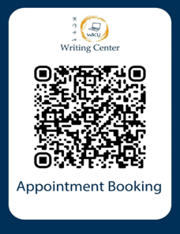

Please join our WeChat Group if you want to **join ECHO-ENG to build the coming *Volume 6***:

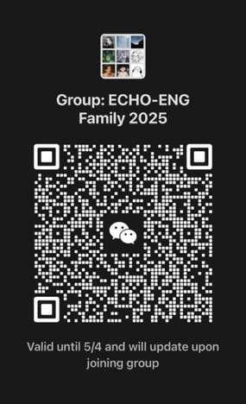

We sincerely welcome your contributions!

Please contact ECHO-ENG via email at [echo-eng@wku.edu.cn](mailto:echo-eng@wku.edu.cn) if you have any questions.

Best regards,

ECHO-ENG Team 2025