Edited on April 16, 2024
ECHO-ENG Issue 5 Open Submissions 第五刊物开放征稿
(Latest Version) Submission Guidelines 最新版征稿指南
April 10 – September 4, 2024
Website Text 网站文稿

ECHO-ENG English Journal Issue 5 – Open Submissions
[English Version]

Dear WKU students,
Wenzhou-Kean University student-run English journal ECHO-ENG is seeking submissions for the fifth issue.
This issue will mainly publish fiction, poetry, creative non-fiction, and student research papers.
Please check the Submission Guidelines for the fifth issue below.
ECHO-ENG sincerely welcomes your submissions that express your unique voice.

Submission Guidelines
Genres
- Fiction: up to three (3) works of fiction, a maximum of 5,000 words each.
- Poetry: up to five (5) poems, a maximum of 1,500 words each.
- Creative Non-Fiction: up to three (3) works of creative non-fiction, a maximum of 5,000 words each.
- Student Research Paper: up to one (1) research paper—maximum 8,000 words. The topic should relate to humanities and social sciences.
- Drama: up to two (2) plays—maximum 5,000 words each.
- Electronic Literature: up to two (2) electronic literature pieces.
- Movie/book reviews: up to three (3) movie or book reviews—maximum 1,000 words each.
- Original Literary Translations: follow submission requirements for the above genres; submissions should include both English and Chinese languages—maximum 5,000 words each.

Format:
- Typed, double-spaced.
- 1” margins on all sides, left-justified.
- Times New Roman/SimSun(中易宋体), size 12.
- Submit in a Word document (.doc or .docx).
- All works require a title.
- Create a separate End Page for the submitted Word document: your Kean email address, your name, student ID, word count of each work, and submission date.

- Fiction, creative non-fiction, and Drama: indent using the tab key at the beginning of every paragraph.
- Poetry: put all poems into a single Word document.
- Student Research Paper: consistently follow MLA or APA standard style.
- Electronic Literature: provide a summary of less than 500 words and attach a URL to the email.
- Movie/Book Review: provide a summary of less than 500 words and attach a URL of the corresponding movie or book.

Artificial Intelligence(AI) Policy:
- Submissions must be the original work of human writers.
- We currently do not accept works solely or predominantly generated by AI systems.
- ECHO-ENG requires that authors disclose and explain any use of AI-assisted technologies in any part of the work on both the manuscript and the End Page.
- In the future, ECHO-ENG might develop certain kinds of submissions where AI writing can be permitted.

Publication:
- Your submission means you agree that your works can be collected in WIRE (Wenzhou-Kean University Intellectual Research Environment at www.wkuwire.org.).
- All accepted submissions will be published in ECHO-ENG Issue 5, hosted on WIRE.
- You should first inform WIRE and ECHO-ENG if your works will be submitted and published in other periodicals in the future.

Submit:
- Submission email address: echo-eng@googlegroups.com (use student Kean email)
- Email Subject: Issue 5 + your name + genre
- Email Body: paste the attached Word document’s End Page
- Due date: 5 pm on September 4, 2024
- Language: Both English and Chinese writings are accepted. The original Chinese writings should have the translated English text submitted in the same Word document.
- Latest Submission Guidelines: Also published on ECHO-ENG’s website: https://club.wku.edu.cn/club/activities/108 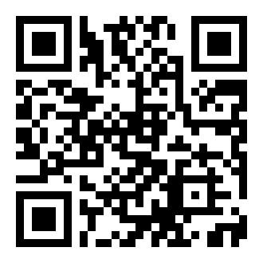

Notes:
- Please include the course title and the instructor on the Word document's End Page if your work is for classes.
- Writers of accepted works will go through a process of revision to polish their writings with experienced professors from the College of Liberal Arts who formed ECHO-ENG’s Review Committee, gaining insight into creative writing skills, research projects, academic publications, and more.
- The writers can receive a peripheral product of ECHO-ENG when attending the Issue 5 Launch Conference in November 2024.
- Writers of collected works can gain the opportunity to host Readers Meeting and attend writing workshops as guest speakers with ECHO-ENG.

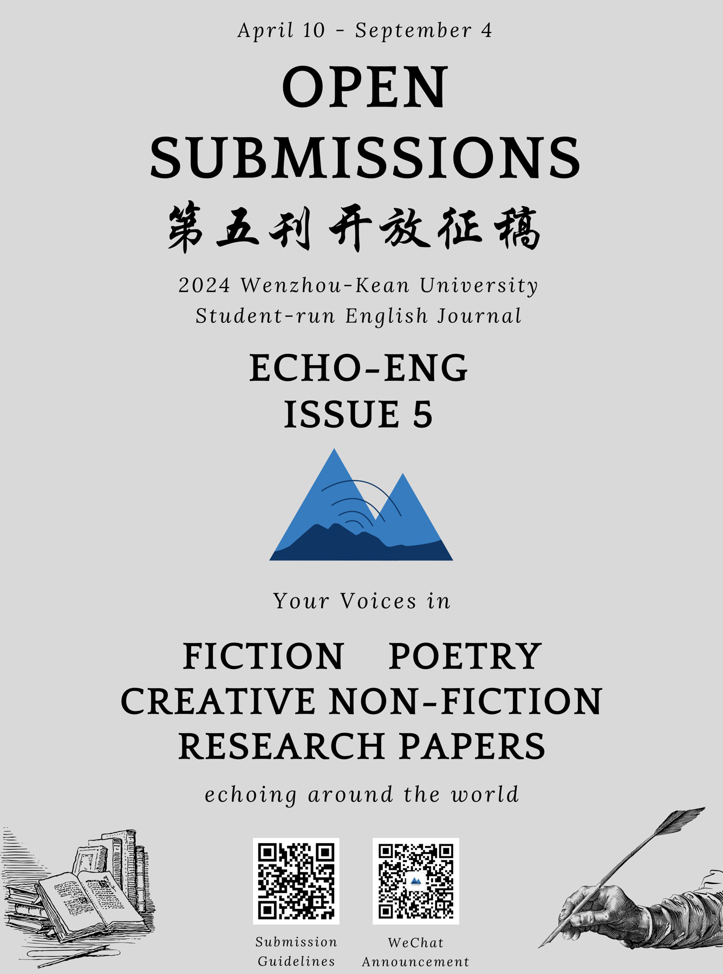

ECHO-ENG英文期刊第五刊—开放征稿
【中文版】

温肯学子们，
温州肯恩大学学生自主运营的英文期刊 ECHO-ENG正在征集 2024 年第五刊的投稿。本刊将主要发表小说、诗歌、创意非小说和学生研究论文。请仔细查看以下第五刊征稿指南。ECHO-ENG诚挚欢迎那载着你独特声音的来稿。
征稿指南
体裁:
- 小说：最多三部小说作品,每篇上限 5000 字。
- 诗歌：最多五首诗, 每首上限 1500 字。
- 创意非小说类作品：最多三篇创意非小说类作品，每篇上限 5000 字。
- 学生研究论文：最多提交一篇研究论文，上限 8000 字。选题应涉及人文社科。
- 戏剧：最多两篇戏剧，每篇上限 5000 字。
- 电子文学：最多两篇电子文学。
- 电影/书籍评论：最多三部电影或书评作品，每部不超过1000字。
- 原创文学翻译：遵循以上各体裁的提交要求；来稿须包含中文和英文；每篇上限 5000 字。

格式：
- 打字，双倍行距页面。
- 各边 1英寸页边距，左对齐。
- 字体Times New Roman/ SimSun(中易宋体)，12 号。
- 以Word文档形式提交。
- 所有文章皆须有其标题。
- 在提交的Word文档插入一张独立的末页：涵盖你的美肯邮箱、你的姓名、学生学号、各作品的字数、提交日期。

- 小说、非小说类创意作品和戏剧：每个段落开头插入一个Tab。
- 诗歌：将所有诗歌合并到一个Word文档中。
- 学生研究论文：全文须一致遵循MLA或APA标准格式。
- 电子文学：提供500字以内的摘要，并在电子邮件中附上URL。
- 电影/书籍评论：提供500字以内的摘要，并附上相应电影或书籍的URL。

人工智能（AI）使用规则：
  - 提交的作品必须是人类作家的原创作品。
  - 我们目前不接受完全或主要由人工智能系统生成的作品。
  - ECHO-ENG要求作者在稿件和末页中指明并解释其在作品的任何部分对人工智能辅助技术的任何使用。
  - 将来，ECHO-ENG可能会开发某些允许人工智能写作的征稿类型。

发表：
- 你的投稿表明你已同意你的作品能够被WIRE数据库(Wenzhou-Kean University Intellectual Research Environment at www.wkuwire.org. )收录。
- 所有被采纳的来稿将在由WIRE数据库收录的ECHO-ENG 第五刊中发表。
- 如果你的作品将投稿和发表于其他期刊，你需要先告知WIRE数据库和ECHO-ENG。

提交：
- 提交邮箱地址：echo-eng@googlegroups.com（使用学生美肯邮箱）
- 邮件标题：第5刊+你的姓名+体裁
- 邮件正文：粘贴你所提交的Word文档的末页
- 截止日期：2024年9月4日下午5点
- 语言：接受英文和中文来稿。原创的中文文学作品须在提交的同一Word文档中附上其英文翻译。
- 最新征稿指南：同时在ECHO-ENG的网站发布：https://club.wku.edu.cn/club/activities/108

提示：
- 如果您的作品源于课程，请在Word文档的末页中注明课程标题和讲师。
- 收纳文集的作者将与ECHO-ENG评审委员会中经验丰富的文学院教授和学生编辑一起修改润色作品，深入了解创意写作技巧、研究项目和学术出版过程等。
- 投稿作者们参加2024年11月ECHO-ENG第五刊发布会时可获赠周边一份。
- 收纳文集的作者可与ECHO-ENG协作举办读者见面会、作为演讲嘉宾参加写作工坊等。

Please read the Submission Guidelines carefully and follow the instructions to submit your organized work.
This will help ECHO-ENG improve its efficiency in managing the submissions and contacting you. Thank you for your cooperation.
请仔细阅读征稿指南并按照其操作说明来提交你整理好的作品。
​这将帮助ECHO-ENG提升管理稿件和与你取得联系的效率。感谢你的合作。

More event announcements from ECHO-ENG's WeChat Official Account:
更多活动通知详见ECHO-ENG微信公众号：

ECHO-ENG’s website QR code:
网站二维码：
（This page of Latest Submission Guidelines is in the “All Activity” Section 该页最新征稿指南发布于“所有活动”板块)

Please contact ECHO-ENG via email at
echo-eng@googlegroups.com if you have any questions.
如果有任何问题可邮件ECHO-ENG。

Best Regards,
ECHO-ENG Team
英文期刊ECHO-ENG团队
2024年4月

Edited on April 16, 2024

